**Putting the “Fix’ in Spatial Fix: A Historical Materialist Understanding of Site Selection**

**Abstract:**

Using biography as a method, this paper explores the historical materiality of the concept of site selection through the career of William Applebaum. Little remembered today, Applebaum played a key role in developing applied geographic thought and techniques during the mid-twentieth century in and out of geography and in the boardrooms of corporate America. While Applebaum was never formally employed as an academic geographer, his ideas and connections helped to radically change the landscape of food retailing in the United States, assisted in the development of new avenues for geostatistical models and modes of representation for site selection, and helped to foster the development of the Quantitative Revolution in the 1960s.By charting the historical materiality of site selection and its impacts through Applebaum’s biography, the paper argues that site selection is not a neutral process, and fundamentally employs a logic which prioritizes the maximization of profit through the lens of geographic thinking and techniques.

**Introduction:**

Each academic year, in introductory GIS classes students learn the fundamentals of how to conduct site selection to identify suitable locations for entities. Given that there is no “site selection” button in any GIS product, students must utilize a suite of tools and data along with knowledge of urban geography and of the specific area under study to make useful recommendations. These exercises are largely seen as benign, and even beneficial, in helping students land jobs after graduation, as the marriage of geographic thought and techniques in applied settings. However, as this paper argues, the historical materialist origins of site selection places site selection as an inherent extension of capitalist logics. To articulate this argument, I examine the formation and implementation of site selection through the biography of William Applebaum, a professional geographer who traveled widely between academic geography, business schools, and corporate boardrooms but who’s impact on the discipline, the landscape of food retailing, and the development of site selection has largely been unexamined.

In the 1930s Applebaum laid the framework for early analytical work in the discipline through site selection and in his later years worked as an advocate for applied geography, mentored of key figures of the Quantitative Revolution and a generation of business school graduates, and in consulted in the food retail industry to help solidify site selection as an essential analytic technique. Situating site selection in its historical materialist origins enables a better understanding of how site selection moved from the fringes of the discipline to a key analytical tool that continues to have significant impacts in the current moment. After introducing the theoretical framing and methods, the paper turns to telling the biography of Applebaum, exploring how site selection emerged as key application of geographic techniques before concluding by examining the legacy of Applebaum and site selection.

**Theoretical Framework:**

NOTE for Matt: I think one of the areas I need to fix in this is that I conflate the spatial fix with political economy.

Discussions of the spatial fix have been part of mainstream conversations in geography since Harvey’s (1982) *The Limits to Capital*, and continue to be employed across the discipline to articulate the ways in which capital seeks to overcome apparent limits. The basic argument that capital often looks to space as a way to generate new profits or minimize current liabilities to prolong its power has found credence across and beyond economic geography. Yet as Bok (2019) argues, the deployment of various types of “fixes” utilizes the power of metaphors to generate new and alternative insights into how capital addresses limits in various sectors of the economy at different times. One by-product of this is that “the fix” has become such an engrained term in the discipline, that we “must continually critically think about the metaphors we use” (Barnes, 1991, p. 118). Indeed, the origins of this quote in Barnes (1991) paper examining the origins of the gravity model in economic geography are highly important to this discussion. As he argues, even though the mathematical gravity model itself oftentimes did not fully work, the metaphorical idea of an aspects of physics (gravity) impacting the distribution of an economic phenomena enabled economic geographers to think differently about how economic spaces operated. Metaphors thus create a portal to reconceptualize the world along the lines of an already existing association.

To this end, I argue that “site selection” has become a metaphor in the world of GIScience, being abstracted from its pre-digital roots as an area of economic geography in determining how hyper-local markets operate towards a set of procedures to be followed in a GIS to assist in decision making. In the process of creating this metaphor, GIScientists and economic geographers alike have overlooked the importance of site selection as a key tool of capitalism in putting the “fix” in the spatial fix. Indeed discussions of how the spatial fix actually manifests in the world is often aimed at the meta-level. In other words, geographers that utilize the spatial fix examine the movement of economic activity from one area to another (such as the offshoring of factories from the Europe and North America to East Asia) to articulate and refine larger-scale economic processes (such as globalization). This movement from law seeking towards theory deciphering is part of that larger “cultural turn” in economic geography that occurred in the 1980s and 1990s (Barnes, 2001).

Given the situated histories of both economic geography and critical GIS, this fissure makes sense to a certain extent. As economic geography was in throes of its own competing epistemological battles between the cultural turn, Marxist economic geography, and critical realism—all various responses to the limits of strictly quantitative economic geography—Neil Smith entered into discussion of the impacts of GIS by highlighting their lethal use in the Gulf War (Smith, 1992). This critical perspective denigrated GIS as a mere technical pursuit, as opposed to an intellectual one that further built the discipline. There was significant consternation between the various campus, much of which Schuurman (2000, p. 575) noted was an element of “selective support” in how authors “champion[ed]” particular argument while “caricaturizing the arguments and delivery of antagonists.” The ensuing flame war ultimately led to the 1993 Friday Harbor meeting which led to the increased cooperation between GIS and human geography and the birth of GIS & Society which quickly became critical GIS (Sheppard, 2005). In the earliest report issued after the Friday Harbor meeting that outlined what was to become this movement, the political economic approaches took a backseat, largely relegated a subquestion in the “Social History of GIS” section. Indeed the most sustained engagement with political economic perspectives came from Stan Openshaw—while vociferously dismissive of the role of critical geographic thought in the discipline, he recognized the power GIS had to create social impacts, highlight a hypothetical scenario of how use of a GIS to close excess bank branches had the possibility of disproportionally impacting lower-income individuals (Openshaw, 1996). The basis of this report left the political economy of GIS awkwardly situated either in a purely historical lens or the hands of individuals whose main expertise was not in critical geography. Although there was some work in this vein around this time, for example XXX work on geodemographics or SOMETHING from ground truth, these were exceptions rather than the rule. By the mid-2000s, this scholarship had been eclipsed by other strands of thought, notably critical cartography, public participatory GIS, feminist GIS, and issues of privacy and ethics leading O’Sullivan (2006, p. 787) to argue this area of scholarship was “missing in action.”

Subsequent meetings designed to renew the ethos of the original Friday Harbor meeting continue to call for increased work examining the political economy of GIS (Thatcher et al., 2016), however there remains little work that critically ties together GIS and economic geography. One key exception Thatcher and Imaoka’s (2018) piece calling for geographers to think about where the students teach geospatial methods ultimately go on to do with their education. As they state, “casting away a series of comforting fictions” about the political economic relations between the discipline and industry may allow for a better understanding of the deeply intertwined relations between the two (Thatcher and Imaoka, 2018, p. 6).

Indeed, beyond the realm of GIS, economic geographers have frequently considered the economic dimensions of geographic information. At a more abstract level the recent debates over the status of economic geography in the UK and the increasing shift being included in business schools highlight the underlying tensions between theory and applied work. And more recent empirical work by Wood and Phelps (CITE) highlights the ways in which explicitly geographic techniques have been employed in both historical and contemporary contexts of the “location consulting industry.” Indeed, even the introduction of the phrase “spatial fix” came from a critical discussion of Von Thunen’s model of land use (Harvey, 1981).

**Methods:**

* Challenge of writing a geneaology
* How does biography fit in?
* Advantages and limitations of biography
* Applebaum as a figurehead for a larger group of individuals who were practicing contributing to these ideas
* Applebaum as a marginalized actor in the history of the discipline, but yet privileged in other ways

Given this approach of an assembled technopositionality, it is here where biography method becomes a useful concept from which to articulate these stories. In recent years, telling one’s life story to explain one’s positionality has emerged under the banner of “auto-methods.” Emerging primarily from feminist literatures, these approaches help to situate positionality as an assemblage of the mundane, everyday realities of an individual’s life. These semi-auto-biographical stories enable scholars to better understand and explain how they emerged to they position they are in. The “other side of the coin” so to speak, of this is more traditional forms of biography, where the life story of one individual is deployed as a framework from which to understand geographic theory and its impact. Books such as Smith’s *American Empire* or Wyly’s recent biography of Edward Ackerman are emblematic of this sort of approach. Biography as method has also been employed in historical geography, primarily to explore the emergence of specific types of phenomenon.

As a method, biography can be limiting due for a variety of reasons. First, is that its emphasis on a singular individual tends obscure the role of others in advancing particular ideas. However, given that this paper examines the concept of site selection through the lens of Applebaum’s biography, it is important to not christen Applebaum as the father of site selection, but rather acknowledge that he is a convenient figurehead for many others—geographers, marketers, urban planners, economists, business executives—during this same period that sought to better model, understand, and ultimately influence the urban landscape through site selection.

The second critique is that biography often is limited by the composition of the archival record. This critique is especially relevant given that Applebaum left few records about his own life—in total I had to consult XX different archives to obtain documentation about his life. These archival materials were paired with materials available via genealogy databases such as Ancestory.com and historic academic literature that Applebaum wrote to help round-out my understanding of his life. This mixed approach helps to decenter the traditional manuscript archive as sole of source of information about individuals, while acknowledging that given Applebaum’s position, most records that I found in these manuscript archives were fairly limited.

**Probably need more***

**Empirics:**

William Applebaum: Becoming a Geographer

Born in 1906 in Belarus, Applebaum immigrated to the United States in 1920 and settled with his family in Minnesota. Fluent in three languages by age 18 (English, Russian, and German), he enrolled in the University of Minnesota in 1928 declaring a major in geography where he began to take classes with a young geographer named Richard Hartshorne. Just a few year removed from completing his PhD at the University of Chicago but before his monumental work on the philosophy of geography, Hartshorne’s work was highly focused on the impacts of location in the profitability of trade (1924), how a business could find the “optimum location” for the best efficiency (1927, 1928), and relationship between urban and economic geography (Hartshorne, 1932). As a student, Appelbaum would have been readily exposed to many of these ideas and from his future career, it is clear that these interests in urban and economic geography resonated with him. Graduating at the depths of the Great Depression in 1931, Applebaum was able to secure a fellowship to start his graduate education at the University of Cincinnati under the tutelage of Nevin Fenneman, a physical geographer and a founding member of the AAG. While a seemingly unlikely candidate to supervise a project in urban and economic geography, Fenneman recognized geography’s power as an interdisciplinary subject and its ability to provide solutions to pressing problems. In this vein, in 1922, Fenneman launched the Cincinnati Resource Survey, a five-year effort to document and understand the city’s business and industrial prospects funded by the Commercial Club of Cincinnati (Ryan, 1986). The results, an 86-page report documenting areas for industrial expansion in the city provided highly valuable information for Cincinnati business and industry.

Both Hartshorne and Fenneman’s work can be housed under the umbrella term of commercial geography, an early subfield of geography primarily concerned with descriptive documentation of an area’s key exports and natural resources. Along with environmental determinism this scholarship was important in setting geography apart from geology in the first half of the twentieth century, becoming the foundation for geography departments in business schools (where programs at the University of Pennsylvania, Columbia University, and the University of Florida originally started) and the introduction of commercial geography as an important part of business education (Goode, 1917; Rowley, 1964). While successful in rising the profile of the discipline, some geographers felt that the field was weak. In a ten-page book review of eleven commercial geography books, Isaiah Bowman reflected on commercial geography’s rise within the discipline arguing that its emphasis on “geographical influence” and encyclopedic listing of facts left the subfield weak and out-of-touch with new developments in the discipline even stating that field was still “too feeble and juvenile” to be scientific (Bowman, 1925, 291).

Yet even with these critiques, commercial geography persisted as it provided a useful framework in conducting applied geographic work. Indeed, Applebaum’s “advanced graduate study” was funded by a local Cincinnati biscuit manufacturer, and he was tasked with carrying out a comprehensive land use survey and analysis of the greater Cincinnati suburbs and “secondary commercial areas” to assess their potential for growth. In nine months, he visited 111 different commercial districts, mapping each in detail, and collecting data on the relationship of each district to its surrounding residential area. Applebaum submitted his findings in a two-volume report to the Commercial Club of Cincinnati which were so impressed by it that the report continued to be “used extensively by real estate men and bankers” as late as 1938 (The Cincinnati Enquirer, 1938). This marriage of applied economic geography with economic and urban geographic theory, and nine-months of intensive fieldwork would prove to be an important series of skills and experience for both Applebaum and the discipline.

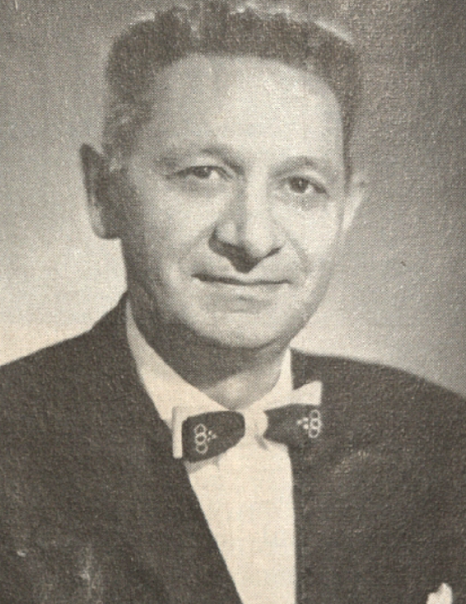

**Figure 1:** William Applebaum, circa 1964. (Harvard Business School Archives, Faculty Biographical Information, William Applebaum, Carton 1, Folder GC 151).

Launching a Professional Career

At the conclusion of his fellowship, Applebaum returned to Minneapolis to undertake PhD work with Hartshorne. However, his time at Minnesota was cut short by a job offer back in Cincinnati and in May 1933, Applebaum was employed by the Kroger Grocery and Baking Company, a local grocer, as a research geographer. Tasked with conducting “studies in urban geography from the standpoint of marketing” (Applebaum, 1942, OSS Application, RG 226, Personnel Files 2166353), his work was critical to the immediate profitability of Kroger and longer-term prospects of food retailing in the United States. In light of the development of geography during this time, Applebaum’s work was original for both its academic content and commercial utility.

Simply put, food retailing in the United States during the 1920s and early 1930s was a highly local affair. In contrast to today’s supermarkets, consumers purchased food goods from small, local corner stores and were served by staff members for each item they sought to purchase (Zimmerman, 1955). However, in the 1920s as the economy boomed, the chain grocery store became a fixture of American prosperity. Centralized purchasing along with low food prices ushered in a period of immense growth in the chain grocery store industry. As these companies grew larger—Kroger for example grew from 779 stores in 1920 to more 5,575 stores in 1930—grocery store chains found the ground underneath them quickly shifting (Deutsch, 2012, 58). Considered as safe bets by Wall Street during the 1920s due to their high stock prices and consistent dividends, the deflationary impact of the Great Depression hurt their business model. Kroger stock, for example, dropped from $120 a share to a little over $36 a share in 1930 alone, all while selling more food than ever in company history (Deutsch, 2012, 135).

While the Great Depression lowered food prices, the costs of maintaining and staffing a large portfolio of small stores, kept food prices high. At the same time, Kroger had made a strategic error early in the Depression. In 1930, a regional manager for Kroger by the name of Michael Cullen wrote to upper management about the prospects for large, self-service, high-volume grocery store. The letter went unanswered and the President of Kroger refused to meet with Cullen even when he made a personal visit to the Cincinnati headquarters, Rebuffed, Cullen quit his job on the spot, moved to New York City, and established the first modern American supermarket (Zimmerman, 1955). His logic proved to be quite promising—using the same business model of bulk buying, selling certain items at discount and marked up prices, and renting a less-than-desirable but large former body shop in Queens—Cullen found great success. In less than 5 years, Cullen had 15 stores and more than a dozen of competitors in the New York market (Zimmerman, 1955).14F Seeing this phenomenon emerge nationwide, Kroger realized that its business model needed to change. The impact of these developments was three-fold: 1) Kroger needed to consolidate their store profile into larger, more modern stores, 2) under-preforming stores needed to be shuttered to free up capital to invest in these new stores, and 3) catering to middle and upper income consumers could provide new ways to bring in more profit (Deutsch, 2012, 140-141).

In order to facilitate these goals, the company established a research division to investigate topics related to food retailing ranging (Phillips, 1936). Applebaum’s work in the division was fundamental to orchestrating how food was distributed to consumers. From the management perspective, establishing new supermarkets was highly risky venture as the company had to shutter existing stores in order to open one large supermarket. Monetary outlays for each individual supermarket were high and required extensive planning to operate. The key factor in all of this—the location of a store and its relation to the rest of city—became of critical importance to alleviate management concerns. Applebaum, armed with intimate knowledge of each of Cincinnati’s suburban shopping districts and advanced knowledge of urban geography, was a natural candidate for this position. Within two years, Applebaum had been promoted to Chief of Staff for the Marketing Research Department, supervising all marketing research for the company (Applebaum, 1942, OSS Application, RG 226, Personnel Files 2166353).

This period of professional success was enhanced by his rising stature within academic geography—although he had no graduate degree, he presented on some of his research methods in constructing population and land use maps to aid in site selection at the 1935 Association of American Geographers conference (Applebaum, 1952, 1). During this era, the Association of American Geographers was a group of elite academic geographers whose membership and participation at annual meetings was carefully guarded and required sponsorship of one’s paper by someone who was a full member (Barnes and Farish, 2006; James et al., 1979). While it is unclear who sponsored the paper, it indicated that a senior academic felt that Applebaum’s work was of general interest to the rest of the discipline. At the same time, he was working with faculty members at Ohio State on land use policies in Cincinnati, with an explicit focus on how to more efficiently plan retail developments (The Cincinnati Enquirer, 1935).

These rudimentary techniques in site selection were tested out in the local surroundings of Cincinnati. In 1927, the city boasted 446 individual grocery stores15F[1]. Six years later more than a hundred outlets had been shuttered, and by 1940 only 247 outlets remained in the city. Moreover, only 27% of the 446 individual stores (a total of 119 stores) were still operating in the same location in 1940 as they were in 1927. Throughout this period, Kroger retained a significant majority of the grocery stores in the city, hovering around 47% of all outlets in the city, even while 46% of its 1927 stores were shuttered. This shift in food retailing practices were guided by Applebaum’s skills in understanding basic site selection. Here, the largest changes in overall grocery stores were located in suburban and majority Black census tracts (Figure 2). These economic logics that manifested themselves in Applebaum’s site selection criteria can be seen for their implementation in the morphology of the built environment.

In suburban areas, land was cheaper to acquire and develop, and in addition, suburbanites were more likely to have access to their own cars which they could use to drive to these new stores. Combined with the lack of home development during the Great Depression, the centralization of grocery stores proved to easier to achieve in the suburbs. In majority Black neighborhoods, consolidation of grocery stores came about due to the impacts of systemic racism, which reduced income and thus profit for individual grocery stores in these neighborhoods, leading to the shuttering of various stores.

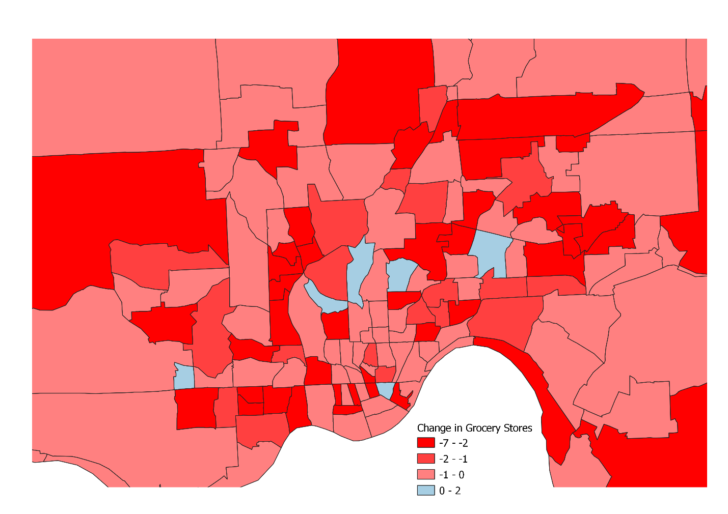

**Figure 2:** Map showing change in overall grocery store count by census tract between 1927 and 1940. (Boundaries from NHGIS, grocery data from Grocerteria).

In 1938, Applebaum moved to Boston to become the Director of Market Research and Coordination for the Economy Grocery Store Corporation, today known as Stop & Shop (The Cincinnati Enquirer, 1938). Making $10,000 a year (equivalent to over $180,000 today), Applebaum was tasked with slimming down Stop & Shop’s footprint while increasing market share. Indeed, Applebaum was able to implement this quite successfully, leading the company to increased profitability in a time of economic scarcity and wartime constrains. As Figure 3 shows, in the nine years from fiscal year 1938 to 1946, Stop & Shop shuttered more than 250 stores while quadrupling overall sales per store (Stop & Shop, Inc., 1946).

**Figure 3:** Stop & Shop Store Consolidation from 1938 to 1946. Not pegged to inflation. (Information from Stop & Shop, Inc., 1946)

Applebaum’s deterministic methodology provided key, actionable recommendations for where a grocery store would succeed. Even if by-and-large the various forms of evidence were based on crude methods and personal understandings of the city, these findings were welcomed due to the overall lack of knowledge on the city in general. Also working in Applebaum’s favor was the industry of choice he worked in: the continuous demand for food mean that it was unlikely for a store to be entirely unprofitable, rather the measure of success was based on the overall rate of return and amount of materialized profits. Additionally, the practice of site selection in general was in its infancy, thus any improvements were welcomed regardless of the logic behind them. This work aligned well with the emergence of marketing as an academic discipline, and Applebaum found himself in high-demand, playing key roles in the formation of the Journal of Marketing and the American Marketing Association (Applebaum, 1966, 1947). However, as Applebaum began to move towards marketing, global events would recommit him to geography.

As the United States ramped up for global war, Richard Hartshorne was asked to Geography division of the Research and Analysis Division of the Office of Strategic Services which later became the CIA. As Trevor Barnes has written the need for detailed regional expertise led to the hiring of hundreds of academic geographers to assist in intelligence analysis. Among Hartshorne’s first hires was Applebaum, as a second-in-command, selected primarily for his extensive experience in handling complex and uncertain issues. By summer 1942, Applebaum had been drafted into the Marines and was serving in the OSS. Critically, the position allowed him interface daily with an extensive set of geographers, many of whom would go onto have a significant impact in the discipline in the post-war era.

Within a year, Applebaum was promoted17F to be the special assistant to head of the entire R&A division, Harvard historian William Langer (Applebaum, 1942, OSS Application, RG 226, Personnel Files 2166353). Fully enmeshed in high-level intelligence operations, coordination between different government agencies, and dispersed OSS units across the globe, Applebaum’s duties revolved around the organization and flow of information, coordinating everything from obtaining space in the Library of Congress for a classified reading room to embarking on a five-month global trip to assist in the streamlining of local OSS outposts in Great Britain, Italy, Algeria, Egypt, India, Ceylon, Burma, and China.

Indeed it was Applebaum’s organizing ability that made him stand out. Unlike other geographers specialized in particular regions or topics, Applebaum’s ability to quickly assemble information to assist in decision-making earned him a reputation as a key piece of OSS’s intelligence capabilities. These skills, honed in conducting research for grocery stores, garnered him significant praise. Donovan himself remarked that Applebaum was “a brilliant organizer” and Colonel David Bruce (later a US Ambassador to France, Germany, and the United Kingdom) stated that he was “an outstanding officer of unparalleled organizational ability” (Mattingly, 1989). In the waning day of the war, Applebaum was even nominated for the Legion of Merit, the highest non-combat medal the military awarded at the time. Although Langer and others felt that Applebaum deserved the award, given that he was only a Lieutenant and not a field-grade officer, his award was reduced to the Bronze Star.

**The Analog Technique:**

In this section, I explore the development of Applebaum’s “analog” technique and its utility to helping businesses. Indeed, as one Applebaum mentee noted in the 1970s, marketing geography was comprised of “a literature whose structure resembles an iceberg -- 90% submerged” (Epstein, 1978). Thus in order to assess Applebaum’s techniques we must examine the literature that he published on, many after his retirement in 1954, when he was finally free to share his ideas with the world. Applebaum published more than 25 different academic pieces, however the most enduring provides the reader with practical instructions for how to determine a store’s potential trading area was published in 1966.

As outlined in this paper, the process involved data collection via customer spotting, interviews with customer about where they lived, their total purchases, and how many people lived in their household, and the collection of storewide metrics (such as daily income). After collecting this data for several days, it became possible to start to construct some basic demographic profiles and tie them to particular geographies, creating an isoline map that showed the distribution of where most of a store’s profits originated. When combined with other information such as up-to-date base maps, census figures, zoning laws, land use maps, ectera it became possible to determine the store’s trading area and its relation to the built environment. This trading area was important to know as it highlighted possible areas for further marketing, what the possible impact of competition from another grocery store might be, and areas far removed from the original store in question where a new store could be located. These exercises helped to narrow the scope of where a new store might located, before being finely calibrated by taking into account the cost and availability of land, road conditions, future development plans, etcetera which could not be modeled.

As Applebaum noted, this “analog” method depended “partly on *quantified experience*, and partly on *subjective judgement*.” It is important to note the use of term “analog” in this context, as a noun not adjective, meaning that analog method was a comparative method as opposed to a predictive method. While it could be, and often was, used to assist in site selection for the construction of new stores, its primary purpose was to estimate and establish the parameters of a particular trading area as it existed. Thus the predictive element existed outside of the realm of the model and in the subjective judgement of the individual conducting the site selection.

***MORE HERE***

**The Peak of His Career:**

With the end of the war, Applebaum returned to Boston and entered into the most productive periods of his career. At Stop & Shop, Applebaum was promoted to the Director of Planning and Coordination and by 1949 was serving as the Assistant General Manager for the entire corporation, which also came with voting privileges on the company’s board of directors (The Boston Globe, 1949). Government work continued, with a consultancy to the National Security Council from 1948-1952, membership on various United States Department of Agriculture research and marketing boards from 1950-1964, and consulting work in India and Yugoslavia as part of the “Food for Peace” program in the 1960s ((Harvard Business School Archives, Faculty Biographical Information, William Applebaum, Carton 2, Folder GB2.152).The Boston Globe, 1964).

More importantly, however, was Applebaum’s recommitment to advancing what he termed “marketing geography” in both the discipline and industry. As he defined it, marketing geography was concerned with “the delimitation and measurement of markets and with the channels of distribution” (246) essentially melding site selection with a larger emphasis on the logistics of retail capitalism. This definition seems to have been heavily influenced by his time at the OSS, where he met a variety of geographers, especially young scholars such as Ed Ullman, Edward Ackerman, and Chauncy Harris that would pioneer urban geography and quantitative methods in the coming years. Back in Boston, with Ackerman and Ullman on the faculty of Harvard geography, connections between professional geographers and a major geography program were bound to occur. Indeed, in early January 1950, *The Boston Globe* ran a full-page article (Figure 4) discussing efforts between *The Globe’s* staff, Applebaum and the Stop & Shop research team, and Harvard geographers and cartographers to produce the first up-to-date map of the Boston metropolitan area in nearly twenty years (Kline, 1950). The undertaking funded by Stop & Shop, supervised by Applebaum and Ullman, and drawn by former OSS cartographers employed by the department, relied on data collected by students who personally “walked through 43 cities and towns, street by street, classifying shopping centers” requiring a new pair of shoes every two weeks. As *The Globe* noted, “most developments since 1928 were not mapped on any one base map” rendering the ability to see an accurate version of the entire metropolitan area impossible (Kline, 1950). Moreover, while initially developed for siting of new stores, it was though there would be “wide application to other commercial and public activities” including city planning, real estate development, mortgage appraisal, research in urban geography, and for marketers. Indeed, the map had already been utilized to evaluate potential sites for the location of tuberculosis x-ray units to ensure that the entire population was covered (Figure 5).

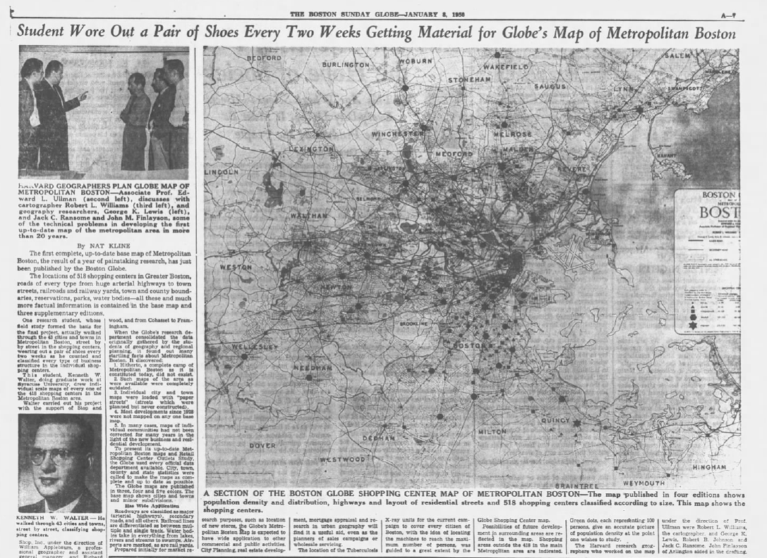

**Figure 4:** Article from *The Boston Globe* documenting Applebaum’s efforts with the Harvard geography program to create a new map of the Boston area (Kline, 1950).

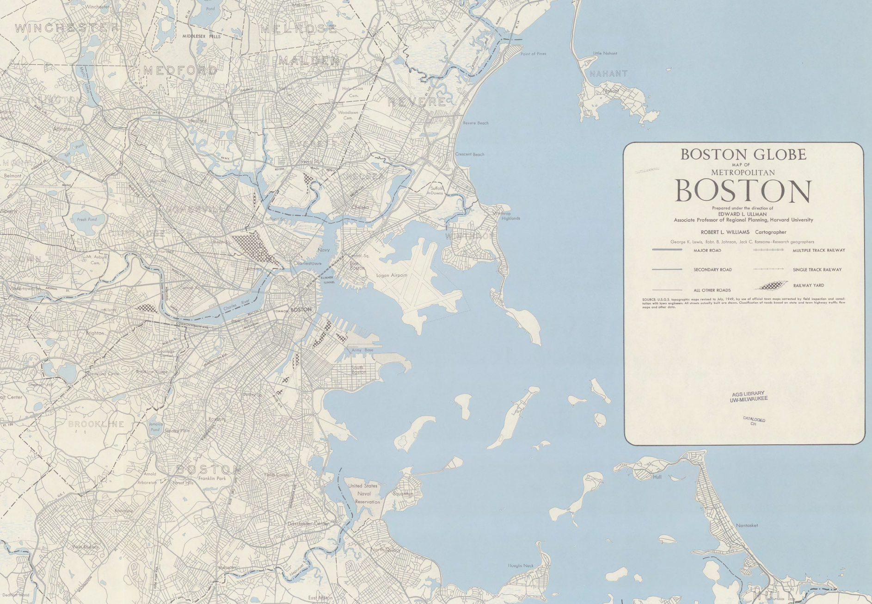

**Figure 5:** Section of the final map produced by the program. Note the large blank space left on the legend, for the printing of additional information at a later time, which is not present in the map in Figure 4. (American Geographical Society Library, University of Wisconsin—Milwaukee).

In this early effort, we see an important linkage connecting industry and academia. Applebaum’s expertise in data collection and fiscal resources along with Ullman’s theories of about urban areas manifested in the creation of this map, allowed entities interested in the greater Boston area to have an accurate and up-to-date understand of the urban landscape. And while sponsored by Stop and Stop and *The Boston Globe*, from both the article and from the blank legend in the archival copy, we see how the map was printed to allow for annotations about various geographic phenomenon to be easily added on the map. In the era before GIS, accurate base maps were essential to conducting basic analysis in site selection.

Given the decision to end the geography program in 1948, the efforts at Harvard largely rested on Ed Ullman’s continued presence in the department, which ended in 1951. With the program slowly withering away, Applebaum stepped in as an informal mentor to many of the remaining graduate students, not only presenting with them at early Regional Science Association meetings but also in helping them secure employment and launch careers. For one student, Howard Green, Applebaum pushed Ullman to approve of his dissertation so he could be hired at Stop & Shop. Green would eventually work for the department store Montgomery Ward and Ford before establishing his own site selection consulting firm in 1965. Green was not the only student that Applebaum helped however: Saul Cohen, the last geography PhD student at Harvard and one of the few Jewish students in geography, was heavily influenced by Applebaum. After Cohen’s graduation in 1956 to the early 1960s, the two worked closely in a variety of business geography projects including both academic texts and consulting work. Cohen ran his own site selection consulting company with Applebaum’s assistance and helped Applebaum run a summer research series underwritten by Kroger to determine its market share in midwestern states which hired an extensive number of geography faculty and graduate students to be carried out (Cohen, 1956). While Cohen later became well known for his writings in political geography, these early research efforts helped him to establish his career.

As Cohen was launching his own academic career, Applebaum was in the process of reinventing his. In 1954, at age 47, Applebaum retired from Stop & Shop all together, beginning consulting work and a new academic career starting as a Visiting Lecturer in Food Distribution with the Harvard Business School. In this new phase of his career, he essentially began to sell his expertise to the highest bidder. While the courses that he taught were not inherently geographical—in the names of the courses, nor in the discussion of topics—the emphasis on distribution and retailing of goods reflected an applied geographic tradition that Applebaum had spent his career developing. With courses like “Retail Merchandizing of Consumer Goods” and “Strategy Problems in Mass Distribution,” Applebaum imparted a career’s worth of knowledge of the mass retailing business to a generation of Harvard Business School students (Harvard University, 1958). In the context of 1950s and 1960s—a period of unprecedented growth in the size of business and American consumerism—Applebaum’s classes were an important contribution to the growth of this system. It also kept geographic work alive at Harvard until the establishment of the Laboratory for Computer Graphics in 196X.

With the benefit of hindsight, it is clear that much of this growth in suburban shopping was underpinned by business school graduates. The entire process of development—from the identification of a new markets, the selection of possible sites, the negotiation process, and the ultimate opening of new businesses was increasingly orchestrated by professionals trained in the process of marketing and economics of business, instead of geographers. Indeed, Applebaum reinforced his skills by continuing consulting work, becoming a member of the Board of Directors of Hannaford Brothers, a grocery wholesaler based in Maine. Here Applebaum helped the company navigate the complex landscape of food retailing, helping grow the company and shift from many small accounts to “fewer but larger accounts.” (DISSERTATION). By the late 1950s, he was helping them establish retail operations which helped the company expand its presence throughout New England. Recognizing Applebaum’s importance to the emergence consumer economy, Applebaum’s position at Harvard became permanent in 1960 (Harvard Business School Archives, Faculty Biographical Information, William Applebaum, Carton 2, Folder GB2.152). Working with Cohen extensively, Applebaum’s publications and reputation continued to increase in the discipline and along with it came recognition and high-level service opportunities. Frequent speaking engagements at geography programs including Clark University, the University of Wisconsin, and Stanford University occurred, and there even was discussion of a Professorship at the University of Washington’s business school. (Harvard Business School Archives, Faculty Biographical Information, William Applebaum, Carton 2, Folder GB2.152). In recognition of his service and contributions, in 1959, the Association of American Geographers awarded him the Citation of Merit, then the highest award that the Association of American Geographers then gave out to members (American Association of Geographers, n.d.).

**Competing Models and the Quantitative Revolution:**

Just as Applebaum was hitting his stride, challenges to his work were emerging in the late 1950s. His work sat a strange interface of the discipline: was inherently quantitative for in its data collection and analysis, yet it was also regionalisitic, based on extensive fieldwork and often examining the micro-regions of a stores market area. Moreover, his work was too practical, not theoretical in the slightest, and did not fit neatly in either the established disciplinary paradigm of regionalism or the emerging one of quantification. Thus, similar to commercial geography in the 1920s and the attacks by Bowman that it was not scientific, Applebaum’s work in marketing geography attracted few other researchers. At the same time, it is impossible to ignore that Applebaum’s lack of an academic position, graduate degrees, and Jewish faith likely left him a marginal player in an increasingly professionalized academy (Kobayashi, 2014).

In fact, these challenges were often acknowledged with one author stating that site selection was an applied and not inherently “purely academic” subject, outside of the mainstream of geographic thought to the point that Applebaum had to campaign “for the subject as a visiting lecturer to the Harvard Graduate School of Business Studies [sic], rather than establishing himself within a geography department” (Davies, 1976, 3). While such a bold statement may not truly reflect Applebaum’s desires, it does speak to the failure to integrate Applebaum into the discipline.

Regardless of the reason Applebaum’s version of marketing geography was not fully taken up within the discipline, its connections to industry and economic development meant quantifying marketing geography was promising area of research in the late 1950s. As Garrison and his graduate students developed their quantitative skills measuring and predicting land use pattern and interstate highway traffic, individual dissertation projects emerged that more explicitly tied quantification toward economic growth. Brian Berry’s 1958 dissertation, a quantitative and Central Place Theory-informed view to the development of shopping centers in Spokane, Washington, directly built off of the previous work that Applebaum had conducted in Cincinnati and Boston. As he wrote in his dissertation, both of these studies were a failure “to identify precise hierarchical structuring of urban business, and also what is recognized in this study as the supplies-repair-arterial business confirmation…”. In this lens, Applebaum’s work (and the work of marketing geography as a subdiscipline) was not theoretical in the sense that it was not law seeking.

Yet perhaps the biggest bridge between the applied and the theoretical was the work of David Huff. Huff, who in later years was considered a Garrison advisee actually earned his Doctor of Business Administration degree at the University of Washington instead of a PhD in Geography. His dissertation examining **XXX**, led to the development a formula to estimate the probability that an individual would visit a store based on their location in space. Introduced in 1962, the model (commonly referred to as the “Huff Model”) was readily taken up and continues to be used today in all sorts of applications, even coming as a prebuilt model in most commercial GIS products. Just a year later (CHECK THIS), Huff transitioned from the UCLA business school to the regional science program at Kansas and ultimately the geography program at UT-Austin.

The differences between Applebaum’s “analog” approach and the “quantitative” approach of the Space Cadets revolved around where prediction fell in the process and how

. Huff and Berry’s work was much more about modeling potential demand for a phenomenon in a given location, while Applebaum’s was more about determining how appropriate a given site was. Although these epistemological differences made good fodder for academic journals, in business the difference was less pronounced, with practitioner stating that quantitative and analog methods were “used precisely in the same way.” From one practitioner’s perspective of starting his career in the early 1960s, he noted that that one’s geographic location played a larger role in which type of site selection methods one utilized, with those on the West Coast utilized quantitative methods while those on the East Coast utilized analog methods before businesses turned to utilizing both depending on their needs in subsequent decades (Thompson, 1982).

Regardless of the intensity of these remarks, it remains clear that Applebaum was a key node in the development of the Quantitative Revolution. While there is no evidence that programmed a computer himself, he supported the transitions within the discipline earnestly. He was an early advocate for embracing computing in geography research and even served as a committee member of Office of Naval Research grants committee which funded much early quantitative geography work from 1958-1961. The same sort of help he extended to his Harvard mentees was extended to the early quantifiers, and Applebaum worked with young quantitative scholars like Brian Berry to find them summer consulting work to increase their incomes and find ways to put their skills to use. And when Harold Fisher brough the Laboratory for Computer Graphics to Harvard and began to create the early programs that became today’s GIS, Applebaum worked with him to produce one of the first computer site selection maps (Figure 6). The efforts helped to extend his legacy far beyond his own lifetime.

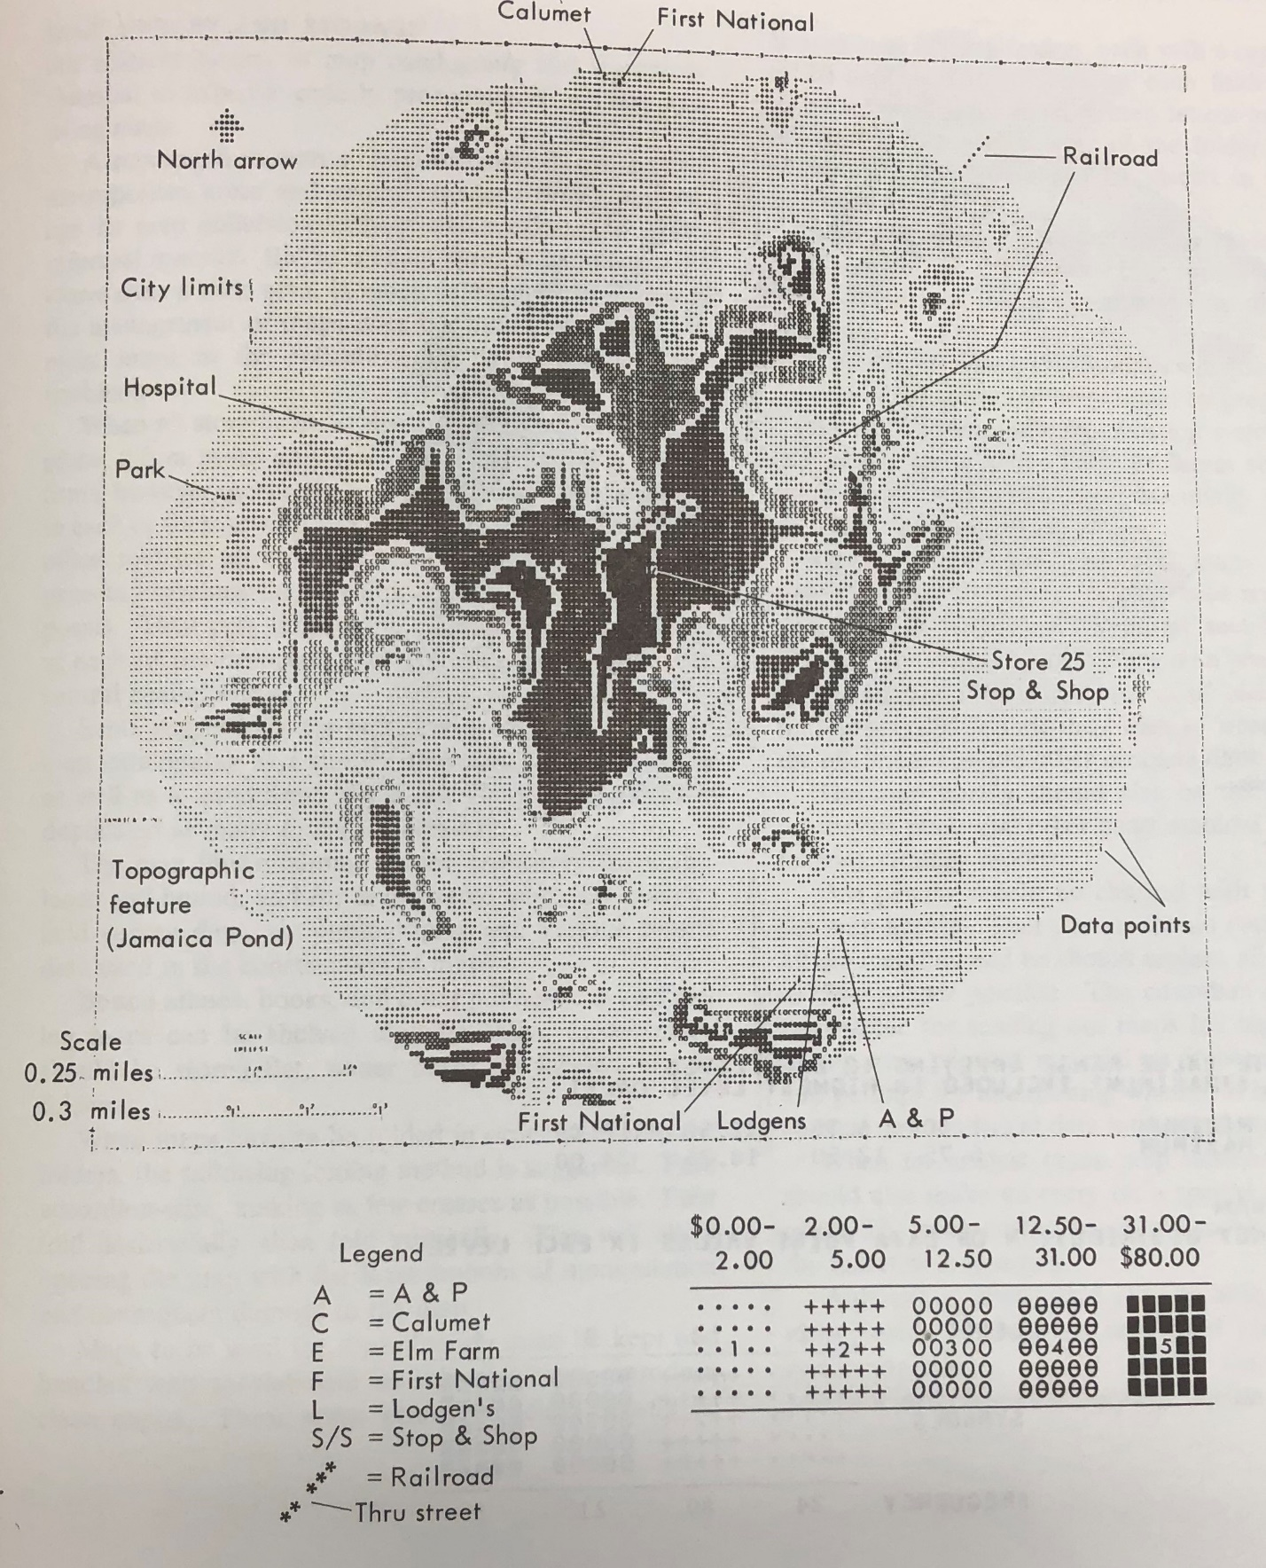

**Figure 6:** Early SYMAP output of supermarkets in the Greater Boston Area indicating average weekly value of groceries sold. (Applebaum, 1968)

**Applebaum’s Legacy: Applied Geography, Site Selection, and the Birth of Radical Geography**

After more than a decade of teaching at Harvard, Applebaum officially retired in 1968 and relocated to Florida part-time where he continued consulting and publishing, selling his techniques in the form of textbooks. Applebaum would die in 1978, contributing to his fields of knowledge until a few years before his death (Harvard University, 2005).

That same year, Bart Epstein, an Applebaum mentee chronicled the past 45 years of marketing geography, back to early days of Applebaum’s career. In so, he talked about the struggle in getting the discipline to recognize his and the fields contributions, arguing that it was only in the late 1950s, for a brief period, that the discipline truly recognized the contributions that Applebaum helped in marshalling. After that, the field gave way to a rigid dichotomy between the academic and the practitioner, with the academic and their publicly available publications overshadowing the confidential and applied work of the practitioner. In the field of business geography, Applebaum continues to be recognized for his contributions with some even calling him the “Father” of marketing geography.

Of course, his legacy goes on beyond this. Most importantly, is his legacy in reforming the built landscape of the food retail industry to prioritize size, scale, efficiency, and profit over all else. As Applebaum wrote in a 1964 trade publication, “… most companies address their research to the question, ‘Will this location be profitable?’, rather than to the more important question, ‘Where are the most profitable sites for us?’” (Harvard Business School Archives). Under this rubric, poorer, disenfranchised communities were more likely to have their grocery stores shuttered or not have a new supermarket built, creating the beginnings of the food desert but also the logics through which they would be created in the future. Moreover, his work in linking business and geography provided an additional political economy to the Quantitative Revolution, placing tangible material advantages in the hands of those who worked on it.

By 1966, food studies scholars had begun to document the lack of available food in urban areas (Beaulac et al., 2009). By 1970, as smaller chains like A&P began to decline and the large supermarkets well-known to consumers today emerged as the standard in new supermarket construction, places like Cincinnati continued to see the number of supermarkets decline. More than thirty years after Applebaum’s departure from Cincinnati, in 1971 had a total 54 stores within the city limits, a decline in 193 grocery stores from 1940 (Gwynn, n.d.). It is ironic then, that the direct impact of Applebaum’s expertise would lead to the rise of critical geography, and sustained critical analysis and movement to undo Applebaum legacy within the food retailing industry.

Yet ironically, Applebaum’s work has also contributed to geographers being able to address the emergence of the food desert, utilizing the same sorts of logics that created the food desert to at least begin to acknowledge where they exist through tools like GIS. Paradoxically for someone whose main contributions to the discipline were methodological, empirical, and in business relationship, Applebaum had an impact on that formation of radical geography through his protegee Saul Cohen. Using the skills he learned from Applebaum in developing potential business leads, in the early 1960s, Cohen spent time in Washington, DC cultivating contacts among federal government agencies, allowing him understand the needs and desires of major federal funders (Huber et al., 2019). This education, in convincing funders to provide money and in understanding what the federal government was willing to fund, proved to be important to his future work. When hired to led Clark University’s school of geography a year later, he reinvigorated the program largely through grants, winning enough money not only add new faculty lines but also to expand the geography building to accommodate future growth. This expansion at Clark allowed helped to maintain non-quantitative human geography, while many of the hires also birthed the critical and radical revolutions within the discipline.

OTHER USEFUL ITEMS:

His paper, the same one published in *Economic Geography* in 1952, explained how to use of Sanborn fire insurance maps to construct a population and land use map. The implication, when first presented in 1935, began a discussion on how business entities could easily acquire and process relevant geographic information and reflect the set of techniques that Applebaum had used extensively while working with Kroger.

American Association of Geographers, n.d. AAG Honors [WWW Document]. URL http://www.aag.org/honors (accessed 6.9.20).

Applebaum, W., 1968. Guide to Store Location Research with Emphasis on Super Markets. Addison-Wesley Publishing Company, Reading, MA.

Applebaum, W., 1966. Guidelines for a Store-Location Strategy Study. Journal of Marketing 30, 42. https://doi.org/10.2307/1249498

Applebaum, W., 1952. A Technique for Constructing a Population and Urban Land Use Map. Economic Geography 28, 240–243. https://doi.org/10.2307/141199

Applebaum, W., 1947. The Journal of Marketing: The First Ten Years. Journal of Marketing 11, 355–363. https://doi.org/10.2307/1246274

Barnes, T.J., 2001. Retheorizing Economic Geography: From the Quantitative Revolution to the “Cultural Turn.” Annals of the Association of American Geographers 91, 546–565. https://doi.org/10.1111/0004-5608.00258

Barnes, T.J., 1991. Metaphors and Conversations in Economic Geography: Richard Rorty and the Gravity Model. Geografiska Annaler: Series B, Human Geography 73, 111–120. https://doi.org/10.1080/04353684.1991.11879617

Barnes, T.J., Farish, M., 2006. Between Regions: Science, Militarism, and American Geography from World War to Cold War. Annals of the Association of American Geographers 96, 807–826. https://doi.org/10.1111/j.1467-8306.2006.00516.x

Beaulac, J., Kristjansson, E., Cummins, S., 2009. A Systematic Review of Food Deserts, 1966-2007. Prev Chronic Dis 6.

Bok, R., 2019. ‘By our metaphors you shall know us’: The ‘fix’ of geographical political economy. Progress in Human Geography 43, 1087–1108. https://doi.org/10.1177/0309132518804352

Bowman, I., 1925. Commercial Geography as a Science. Reflections on Some Recent Books. Geographical Review 15, 285. https://doi.org/10.2307/208478

Cohen, S.B., 1956. Team Research in Marketing Geography. The Professional Geographer 8, 5–8. https://doi.org/10.1111/j.0033-0124.1956.085_5.x

Davies, R.L., 1976. Marketing Geography: With Special Reference to Retailing. Retail and Planning Associates, Norwich, UK.

Deutsch, T., 2012. Building a Housewife’s Paradise Gender, Politics, and American Grocery Stores in the Twentieth Century. University of North Carolina Press, Chapel Hill, NC.

Goode, J.P., 1917. Report of the N. E. A. Committee on Commercial Geography as An Element in Business Education. Journal of Geography 15, 272–274. https://doi.org/10.1080/00221341708984055

Gwynn, D., n.d. Groceteria.com [WWW Document]. Groceteria.com. URL https://www.groceteria.com/ (accessed 7.27.20).

Hartshorne, R., 1932. The Twin City District: A Unique Form of Urban Landscape. Geographical Review 22, 431–442. https://doi.org/10.2307/208973

Harvard University, 2005. Harvard University History of Named Chairs, Sketches of Donors and Donations: Professorships of the Faculties of Medicine and Public Health, 1721-1992. Harvard University, Cambridge, MA.

Harvard University, 1958. Official Register of Harvard University: Graduate School of Business Administration.

Harvey, D., 1982. The Limits to Capital. Verso Books.

Harvey, D., 1981. The Spatial Fix - Hegel, Von Thunen, and Marx. Antipode 13, 1–12. https://doi.org/10.1111/j.1467-8330.1981.tb00312.x

Huber, M.T., Knudson, C., Tapp, R., 2019. Radical Paradoxes, in: Spatial Histories of Radical Geography. John Wiley & Sons, Ltd, pp. 87–115. https://doi.org/10.1002/9781119404781.ch3

James, P.E., Martin, G.J., De Blij, H.J., Kohn, C.F., 1979. The Association of American Geographers: The First Seventy-Five Years: 1904-1979. Association of American geographers, Washington, D.C.

Kline, N., 1950. Student Wore Out a Pair of Shoes Every Two Weeks Getting Material for Globe’s Map of Metropolitan Boston. The Boston Globe A-7.

Kobayashi, A., 2014. The Dialectic of Race and the Discipline of Geography. Annals of the Association of American Geographers 104, 1101–1115. https://doi.org/10.1080/00045608.2014.958388

Mattingly, R.E., 1989. Herringbone Cloak-GI Dagger, Marines of the OSS, Occasional Papers Series. History and Museum Division Headquarters, United States Marine Corps, Washington, D.C.

Openshaw, S., 1996. GIS and Society: A Lot of Fuss About Very Little That Matters and Not Enough About That Which Does!, in: Harris, T., Weiner, D. (Eds.), GIS and Society: The Social Implications of How People, Space, and Environment Are Represented in GIS. p. 200.

O’Sullivan, D., 2006. Geographical information science: critical GIS. Progress in Human Geography 30, 783–791. https://doi.org/10.1177/0309132506071528

Phillips, C.F., 1936. A History of the Kroger Grocery & Baking Company. National Marketing Review 1, 204–215.

Reese, A.M., 2019. Black Food Geographies: Race, Self-Reliance, and Food Access in Washington, D.C. University of North Carolina Press.

Rowley, V.M., 1964. J. Russell Smith: Geographer, Educator, and Conservationist.

Ryan, B., 1986. Nevin Melancthon Fenneman, in: Freeman, T.W. (Ed.), Geographers, Biobibliographical Studies. Mansell, p. 17.

Schuurman, N., 2000. Trouble in the Heartland: GIS and Its Critics in the 1990s. Progress in Human Geography 24, 569–590. https://doi.org/10.1191/030913200100189111

Sheppard, E., 2005. Knowledge Production through Critical GIS: Genealogy and Prospects. Cartographica: The International Journal for Geographic Information and Geovisualization 40, 5–21. https://doi.org/10.3138/GH27-1847-QP71-7TP7

Smith, N., 1992. History and Philosophy of Geography: Real Wars, Theory Wars. Progress in Human Geography 16, 257–271. https://doi.org/10.1177/030913259201600208

Stop & Shop, Inc., 1946. Annual Report to Stockholders, 1946.

Thatcher, J., Bergmann, L., Ricker, B., Rose-Redwood, R., O’Sullivan, D., Barnes, T.J., Barnesmoore, L.R., Beltz Imaoka, L., Burns, R., Cinnamon, J., Dalton, C.M., Davis, C., Dunn, S., Harvey, F., Jung, J.-K., Kersten, E., Knigge, L., Lally, N., Lin, W., Mahmoudi, D., Martin, M., Payne, W., Sheikh, A., Shelton, T., Sheppard, E., Strother, C.W., Tarr, A., Wilson, M.W., Young, J.C., 2016. Revisiting critical GIS. Environ Plan A 48, 815–824. https://doi.org/10.1177/0308518X15622208

Thatcher, J.E., Imaoka, L.B., 2018. The poverty of GIS theory: Continuing the debates around the political economy of GISystems. The Canadian Geographer / Le Géographe canadien 62, 27–34. https://doi.org/10.1111/cag.12437

The Boston Globe, 1964. 4 Food Experts From N.W. to Advise India. The Boston Globe 12.

The Boston Globe, 1949. Applebaum Named Asst. Gen. Manager of Stop & Shop, Inc. The Boston Globe 13.

The Cincinnati Enquirer, 1938. Kroger Man Resigns. The Cincinnati Enquirer 23.

The Cincinnati Enquirer, 1935. Land Use Study Advocated to Aid Farm and Business. The Cincinnati Enquirer 8.

Zimmerman, M.M., 1955. The Super Market: A Revolution in Distribution. McGraw-Hill Book Company, New York.

1. Data for this section came from Grocerteria.com and the US Census Bureau. I am in debt to Ashanté Reese’s *Black Food Geographies* for discovering this dataset (Reese, 2019).